Project Design Phase-II
Technology Stack (Architecture & Stack)

Date | 5 July 2026
Team ID
Project Name | Nutrition Assistant
Maximum Marks | 4 Marks

Technical Architecture:
The Nutrition Assistant is developed using the MERN Stack Architecture, which consists of MongoDB, Express.js, React.js, and Node.js. The application follows a three-tier architecture comprising the Presentation Layer, Application Layer, and Database Layer.
The Presentation Layer is built using React.js, HTML5, CSS3, and JavaScript. It provides an interactive and responsive user interface for user registration, login, meal logging, dashboard visualization, nutrition tracking, and profile management.
The Application Layer is implemented using Node.js and Express.js. It handles user authentication, JWT-based authorization, meal management, nutrition calculations, profile updates, RESTful API services, and communication between the frontend and the database.
The Database Layer uses MongoDB with Mongoose ODM to store user information, authentication details, nutrition logs, meal history, calorie records, water intake, and exercise data. MongoDB Atlas can be used for cloud deployment and secure data storage.
The application uses JWT (JSON Web Tokens) and bcryptjs to provide secure authentication and password encryption. Axios is used for communication between the React frontend and Express backend through REST APIs.
The architecture is modular, scalable, and maintainable, allowing future enhancements such as AI-based meal recommendations, barcode scanning, wearable device integration, and cloud deployment using Vercel, Render, and MongoDB Atlas.
Example: Order processing during pandemics for offline mode

Reference: https://developer.ibm.com/patterns/ai-powered-backend-system-for-order-processing-during-pandemics/

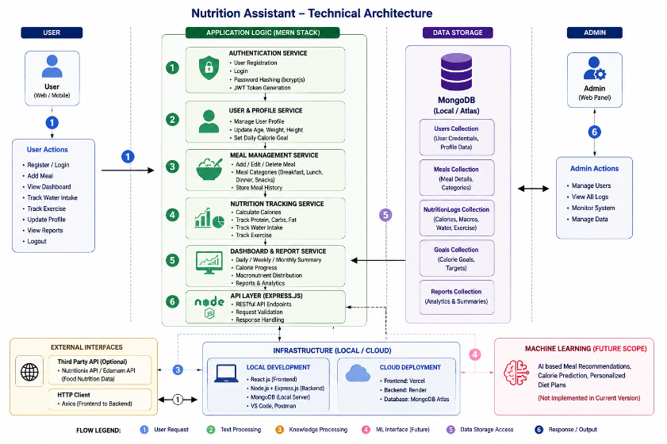
Guidelines:
Include all application processes such as User Registration, Login, JWT Authentication, Dashboard, Meal Management, Nutrition Tracking, Water Intake, Exercise Tracking, Profile Management, and Reports as separate application logic blocks.
Clearly distinguish the infrastructure into Local Development (React.js Frontend, Node.js/Express.js Backend, MongoDB Local Server) and Cloud Deployment (Vercel for Frontend, Render for Backend API, MongoDB Atlas for Database).
Show external interfaces such as REST APIs, Axios HTTP Client, and optional third-party integrations (e.g., Nutritionix API or Edamam API) if implemented.
Indicate data storage components including MongoDB Users Collection, NutritionLogs Collection, Profile Data, and Meal History managed through Mongoose ODM.
Machine Learning integration is not applicable in the current version. It may be extended in future for AI-based meal recommendations, calorie prediction, or personalized diet planning.

Table-1 : Components & Technologies:
S.No | Component | Description | Technology
- 1 | User Interface | Provides the web interface for user registration, login, dashboard statistics, meal logging, and profile management. | HTML5, CSS3, JavaScript (ES6+), React.js, Axios, React Router
- 2 | Application Logic-1 | Handles user authentication, account registration, password hashing, JWT generation, and authorization for protected routes. | Node.js, Express.js, JWT, bcryptjs
- 3 | Application Logic-2 | Manages meal logging, nutrition tracking, calorie calculations, macronutrient analysis, and daily nutrition summaries. | Node.js, Express.js
- 4 | Application Logic-3 | Manages user profiles, health information (age, weight, height), calorie goals, water intake, and exercise tracking. | Node.js, Express.js
- 5 | Database | Stores user credentials, profile information, daily meal records, nutrition logs, and application data. | MongoDB (v6.0+), Mongoose ODM
- 6 | Cloud Database | Provides cloud-based database hosting for secure storage, backup, and synchronization across deployments. | MongoDB Atlas
- 7 | File Storage | Stores project source code, uploaded assets, configuration files, and static resources. | Local File System
- 8 | External API-1 | Third-party nutrition or food database integration (optional for future enhancement). | N/A (Not Implemented)
- 9 | External API-2 | External services for additional health or validation features (optional). | N/A (Not Implemented)
- 10 | Machine Learning Model | AI-based personalized nutrition recommendation module (future enhancement). | N/A (Not Implemented)
- 11 | Infrastructure (Server/Cloud) | Hosts the frontend and backend applications for development and production deployment. | Localhost, Render (Backend API), Vercel (Frontend React Client)

Table-2: Application Characteristics:
S.No. | Characteristics | Description | Technology
 | Open-Source Frameworks | Lists the open-source frameworks and libraries used to develop the full-stack Nutrition Assistant application. | React.js 18, Node.js (v18+), Express.js, MongoDB, Mongoose ODM, Axios, React Router
 | Security Implementations | Implements secure user authentication, password encryption, protected API access, and cross-origin request handling. | JWT (JSON Web Tokens), bcryptjs, Express CORS Middleware, dotenv
 | Scalable Architecture | Uses a modular three-tier MERN architecture with separate frontend, backend, controllers, models, routes, and database layers for easy maintenance and scalability. | 3-Tier MERN Architecture (React.js + Express.js + Node.js + MongoDB), MVC Pattern
 | Availability | Ensures continuous application availability through reliable database connectivity and cloud deployment with automatic recovery mechanisms. | MongoDB Atlas, Render (Backend), Vercel (Frontend), PM2 (Optional)
 | Performance | Optimizes application performance using efficient database queries, indexed collections, React Virtual DOM rendering, and compressed API responses. | MongoDB Indexing, React Virtual DOM, Express.js, Gzip Compression

References:
https://c4model.com/
https://developer.ibm.com/patterns/online-order-processing-system-during-pandemic/
https://www.ibm.com/cloud/architecture
https://aws.amazon.com/architecture
https://medium.com/the-internal-startup/how-to-draw-useful-technical-architecture-diagrams-2d20c9fda90d

